**Name: Mbongeleni Ngcongo**

**GitHub link:** [**https://github.com/mbongelenisgele/CI-CD-Deployment-for-Springboot-Application**](https://github.com/mbongelenisgele/CI-CD-Deployment-for-Springboot-Application)

**CI/CD Deployment for Springboot Application.**

Project 1

This section will guide you to:

* + Launch and connect to an EC2 instance

This lab has three subsections, namely:

1. Write the spring boot program.
2. Launching an EC2 instance
3. Connecting to the EC2 instance
4. Creating S3 Bucket. 5. Added jar file in the bucket.
5. Pushing the files to GitHub repositories

**Step 1: Write spring boot program:**

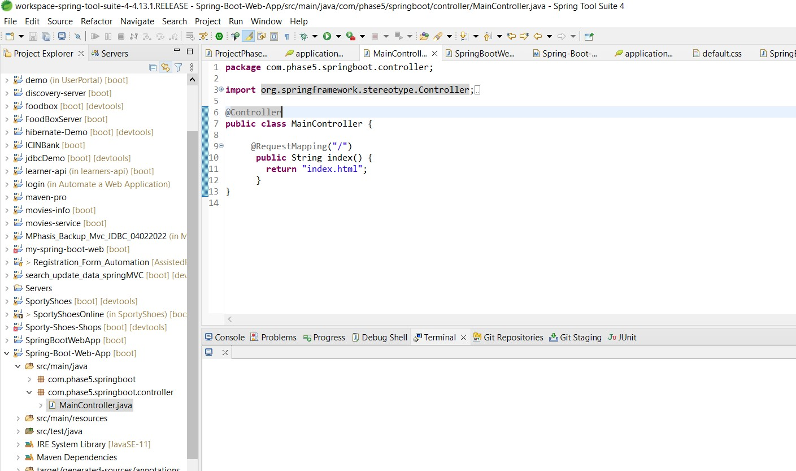

# Step 2: Launching EC2 instance:

1. Click on launch instance to run any instance
2. Select the AMI

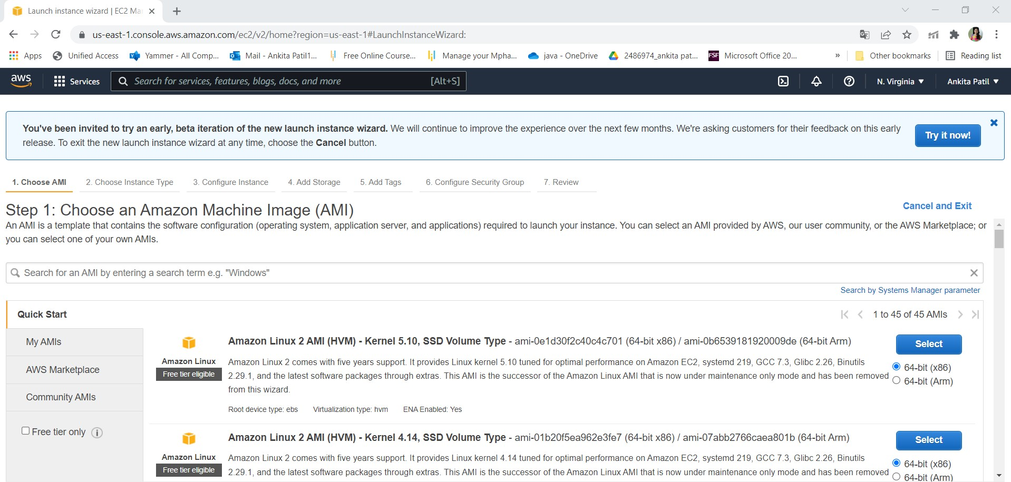

1. Select t2.micro as the instance type

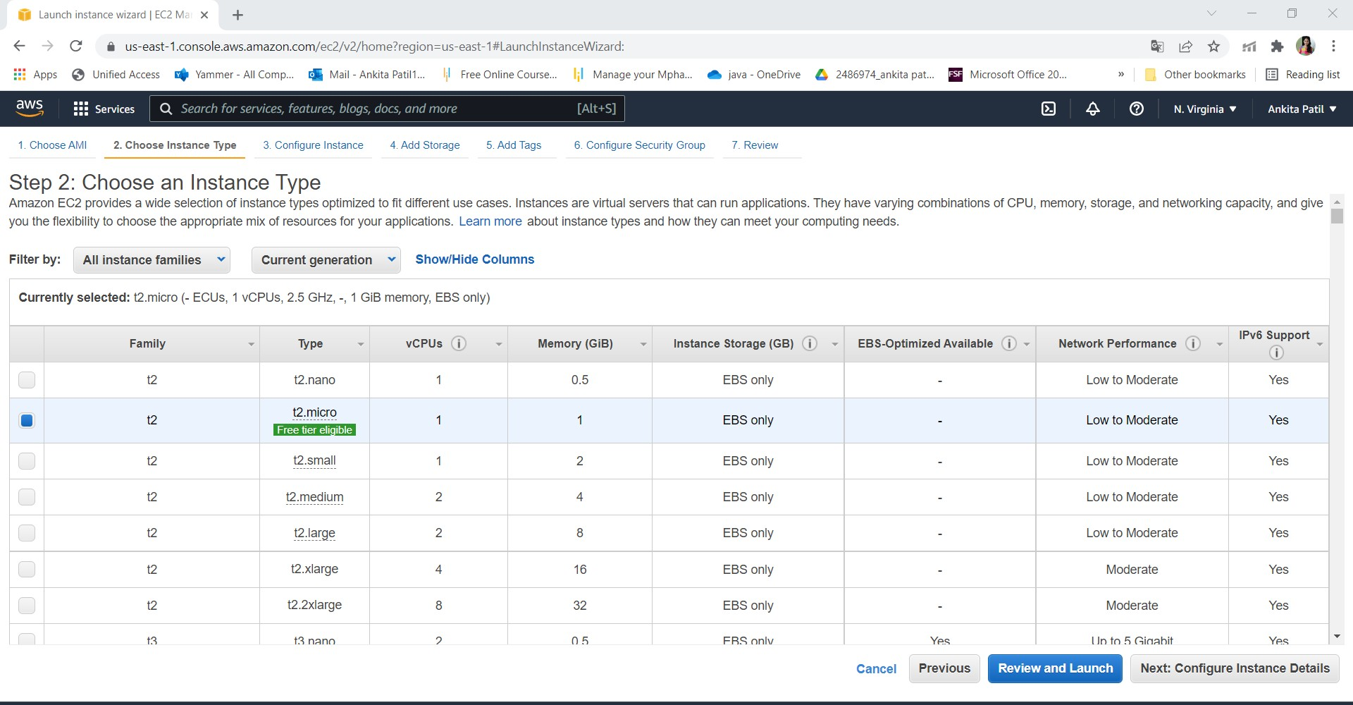

1. Specify the number of instances, networks, placement groups, and IAM roles and click Next

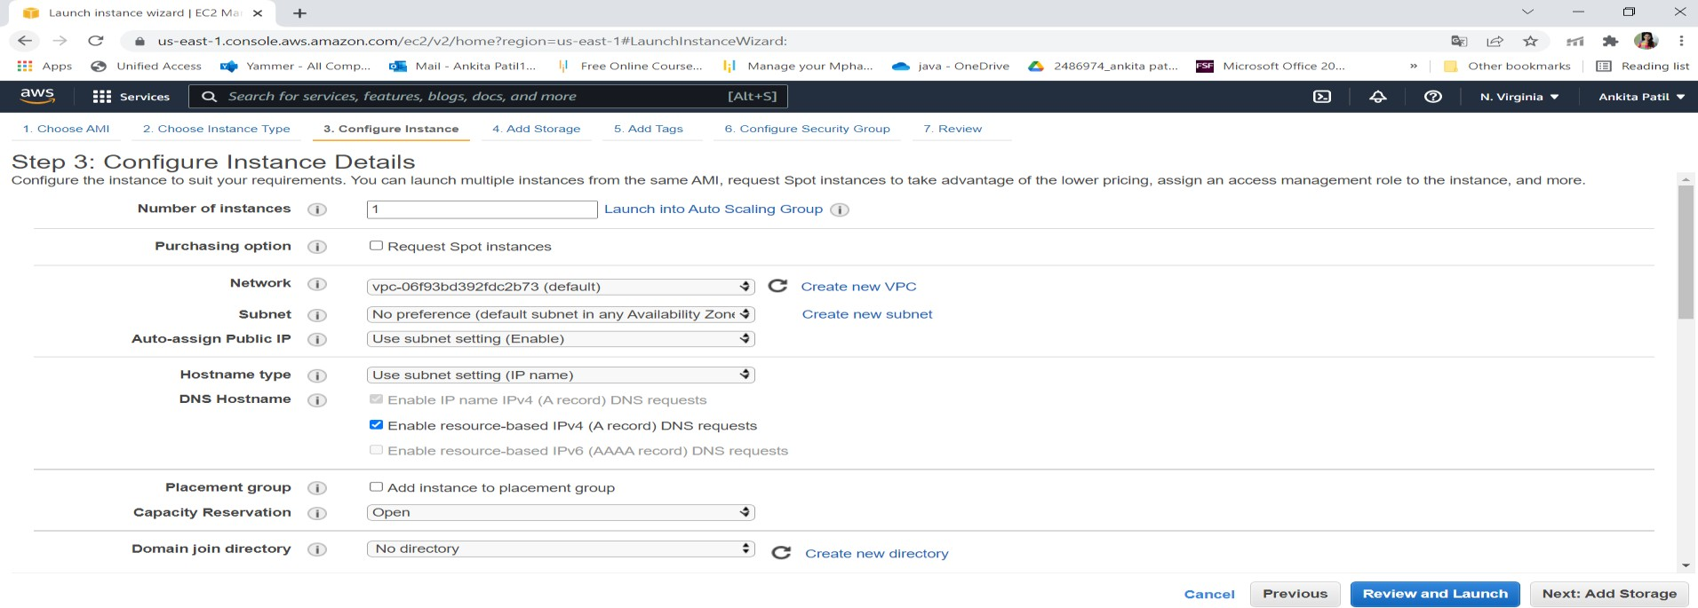

1. Add storage

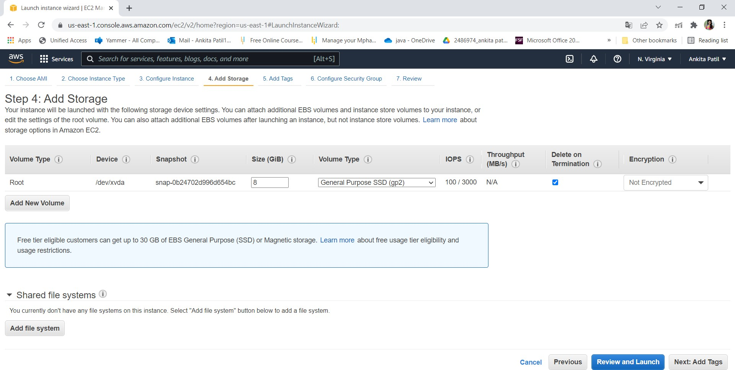

1. You can add a key-value pair to the instance

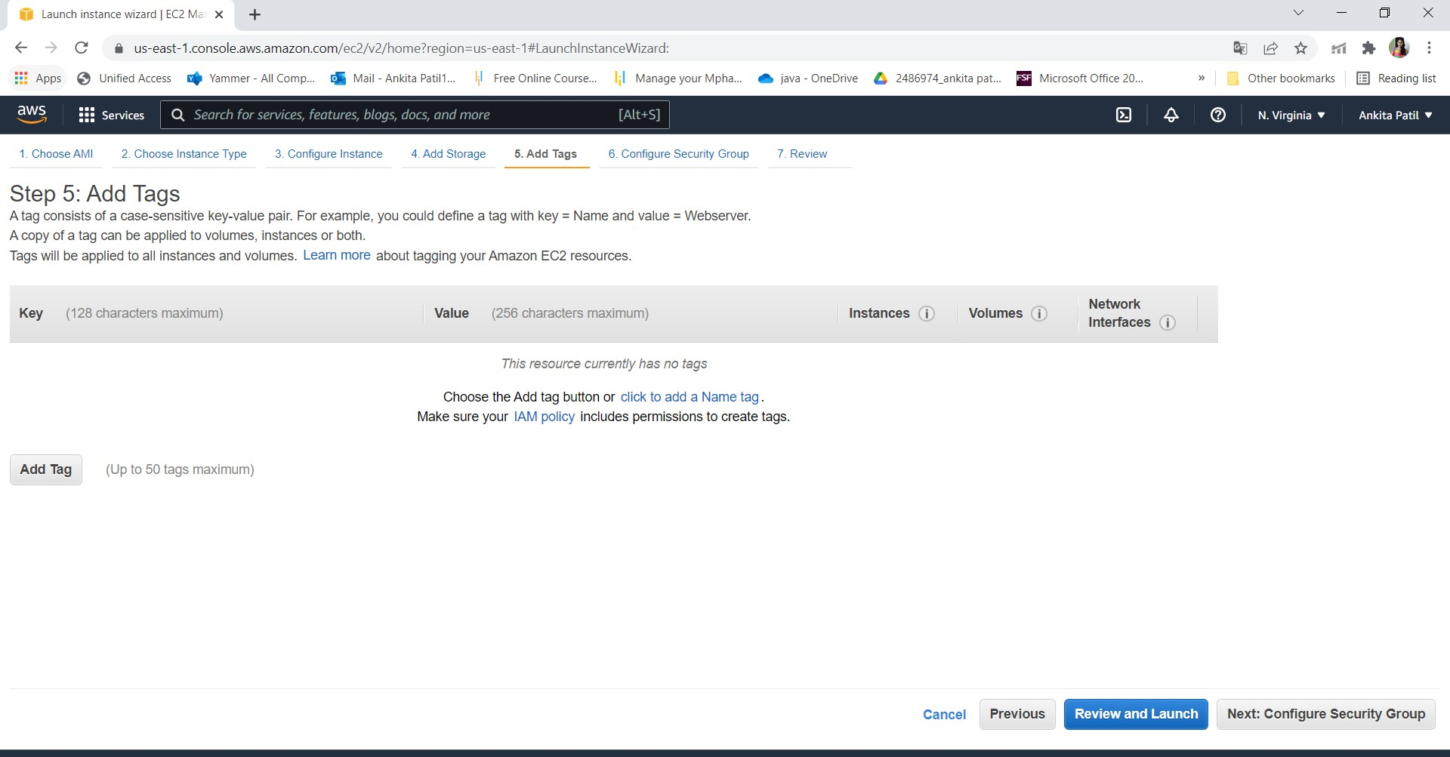

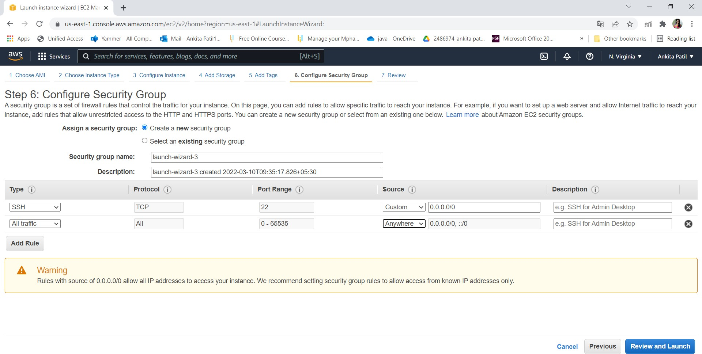

1. Click on launch

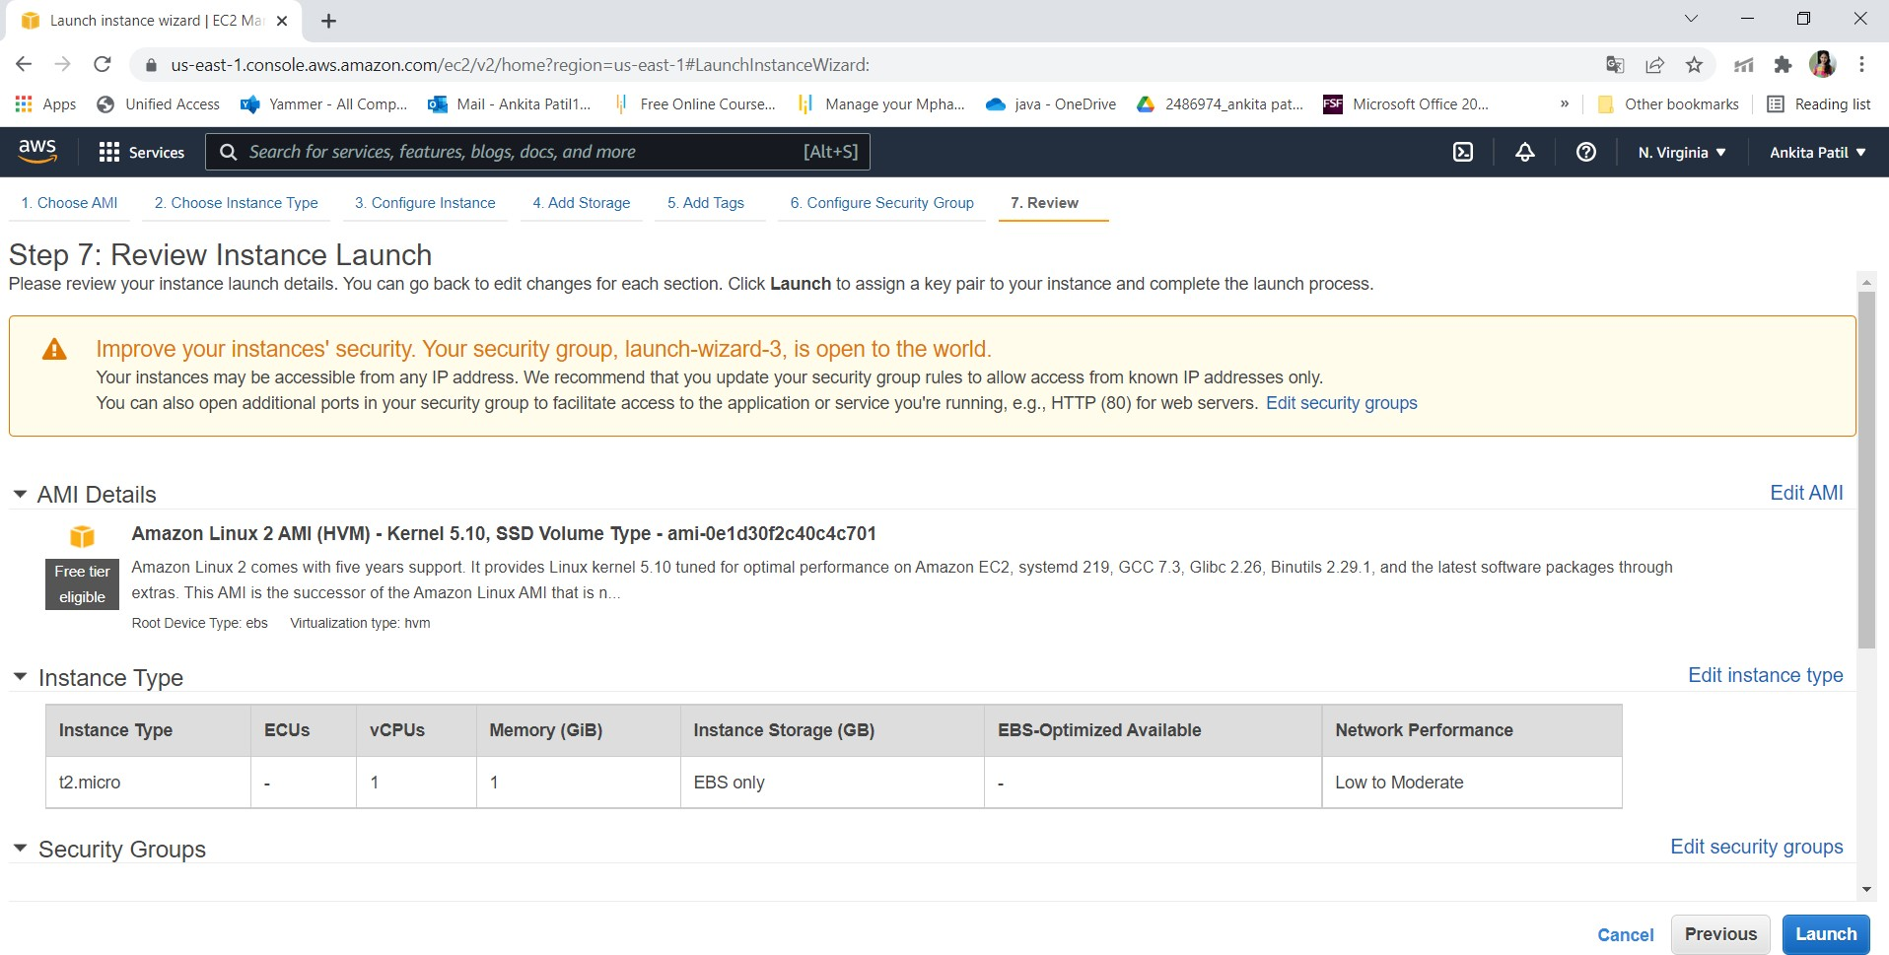

1. Create key pair

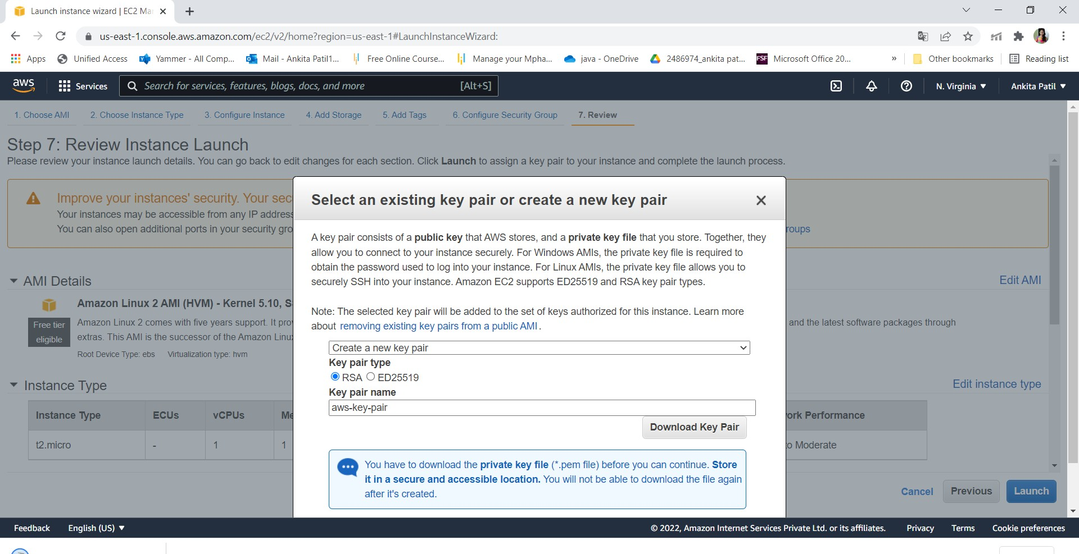

1. Click on the view instance

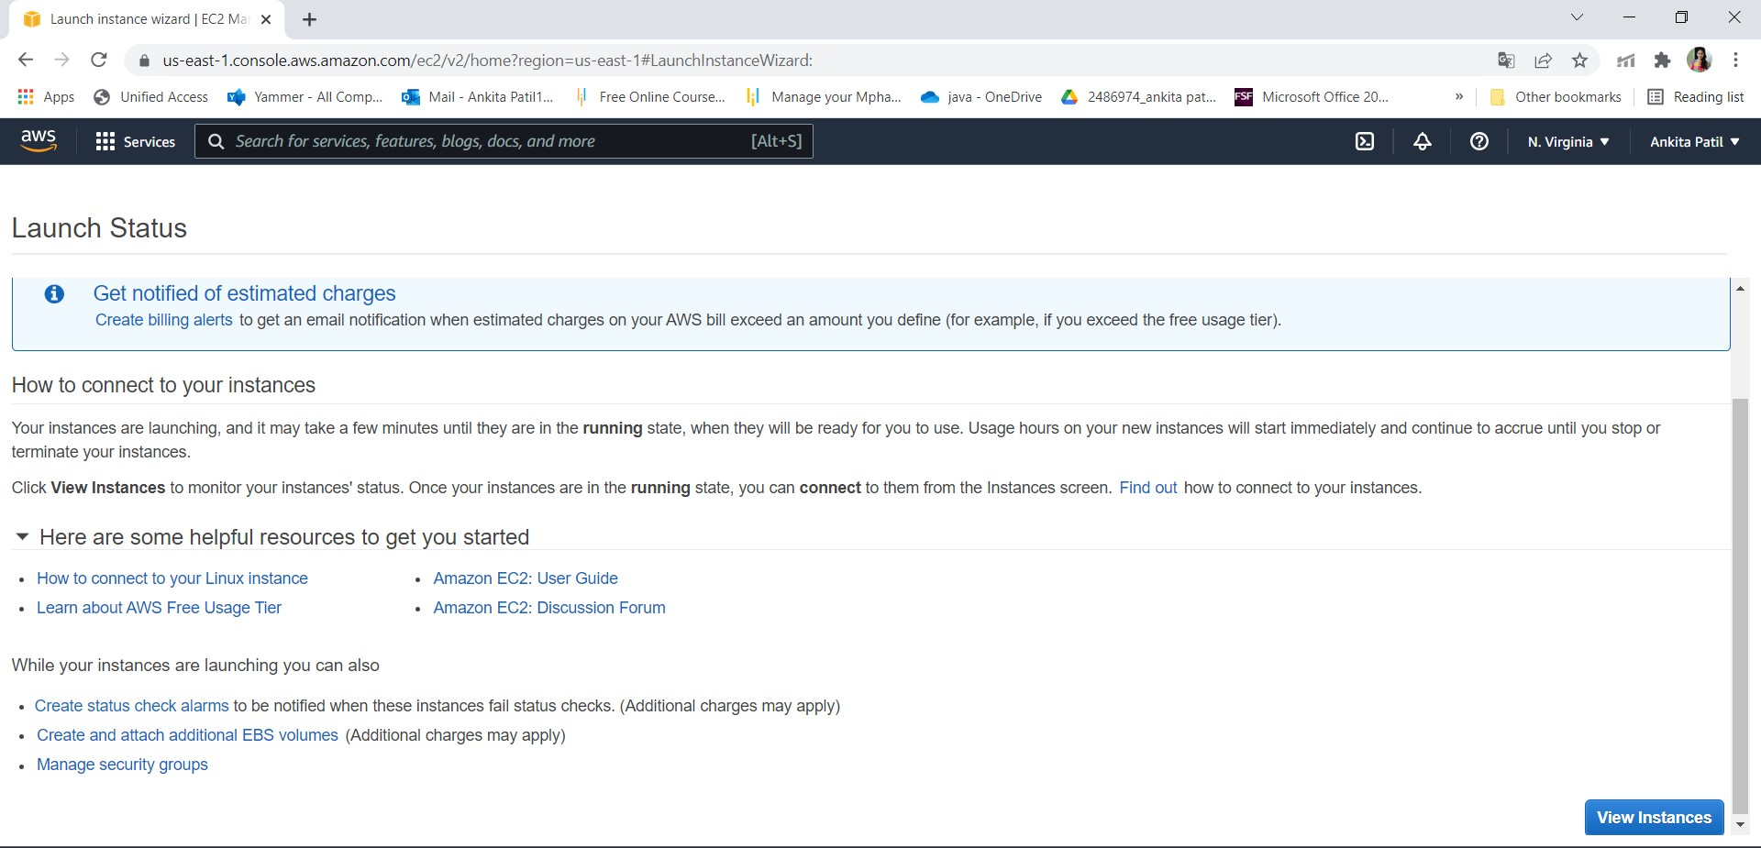

1. Connect the instance

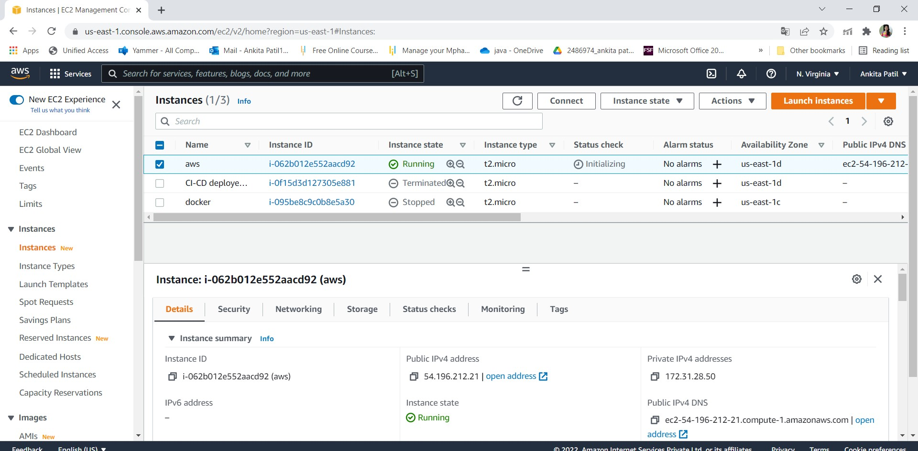

# Step 3: Connect to EC2 instances:

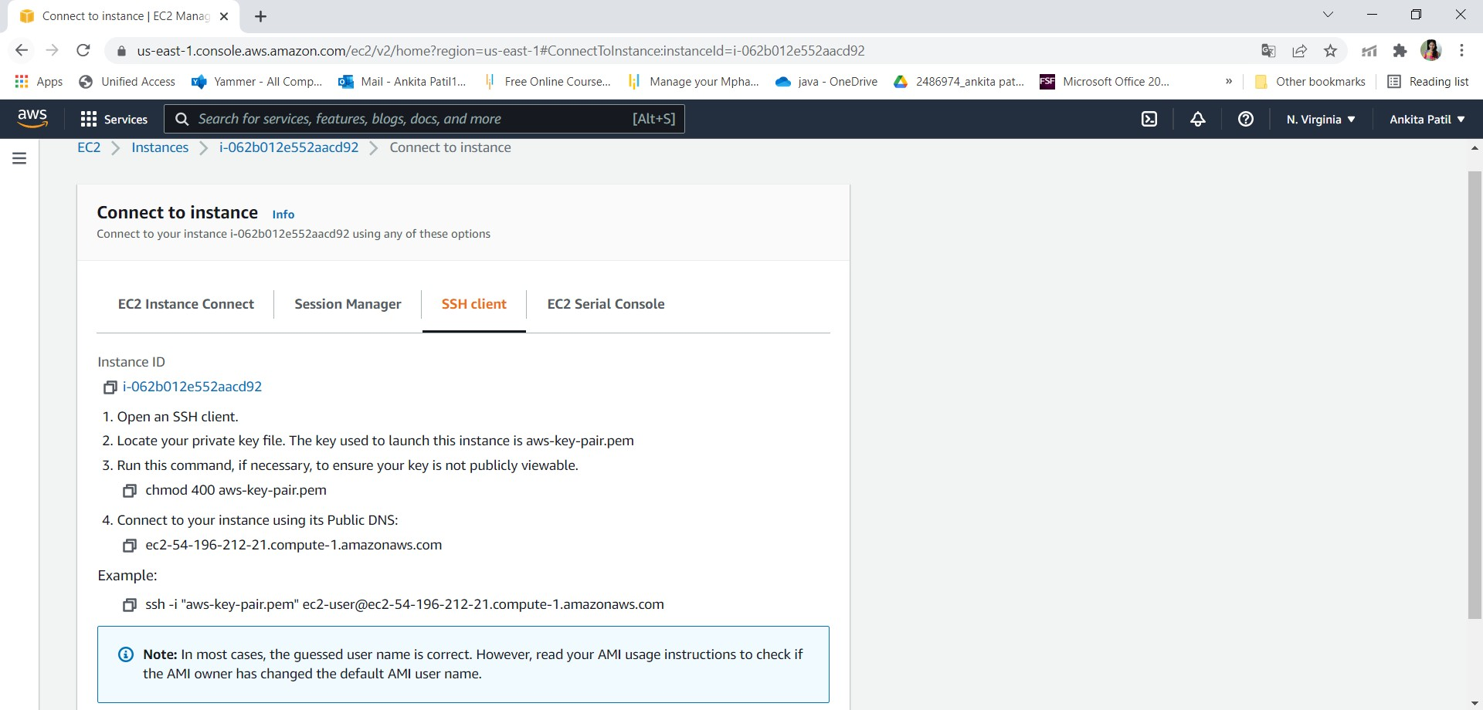

1. Click on Connect on the EC2 dashboard & Run the ssh command provided

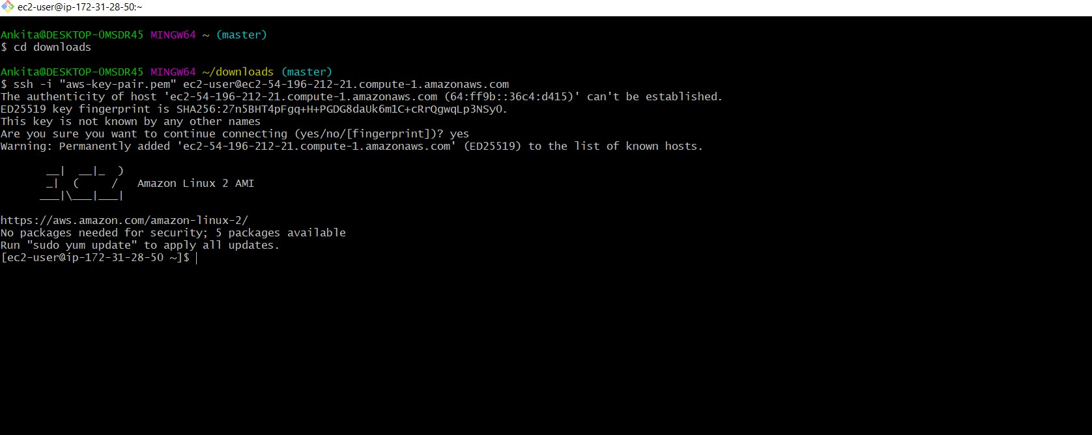

# Step 4: Creating S3 Bucket:

* 1. Create a Bucket to store the jar file:

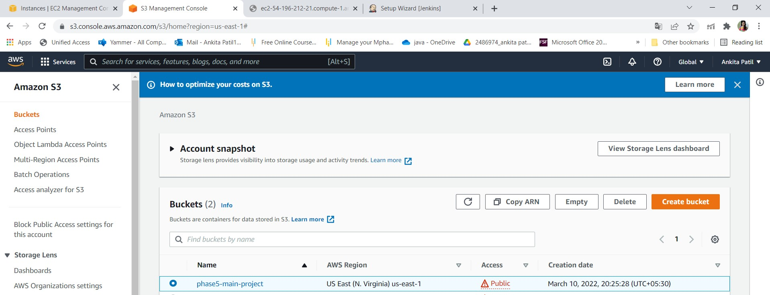

Step 5:Adding jar file:

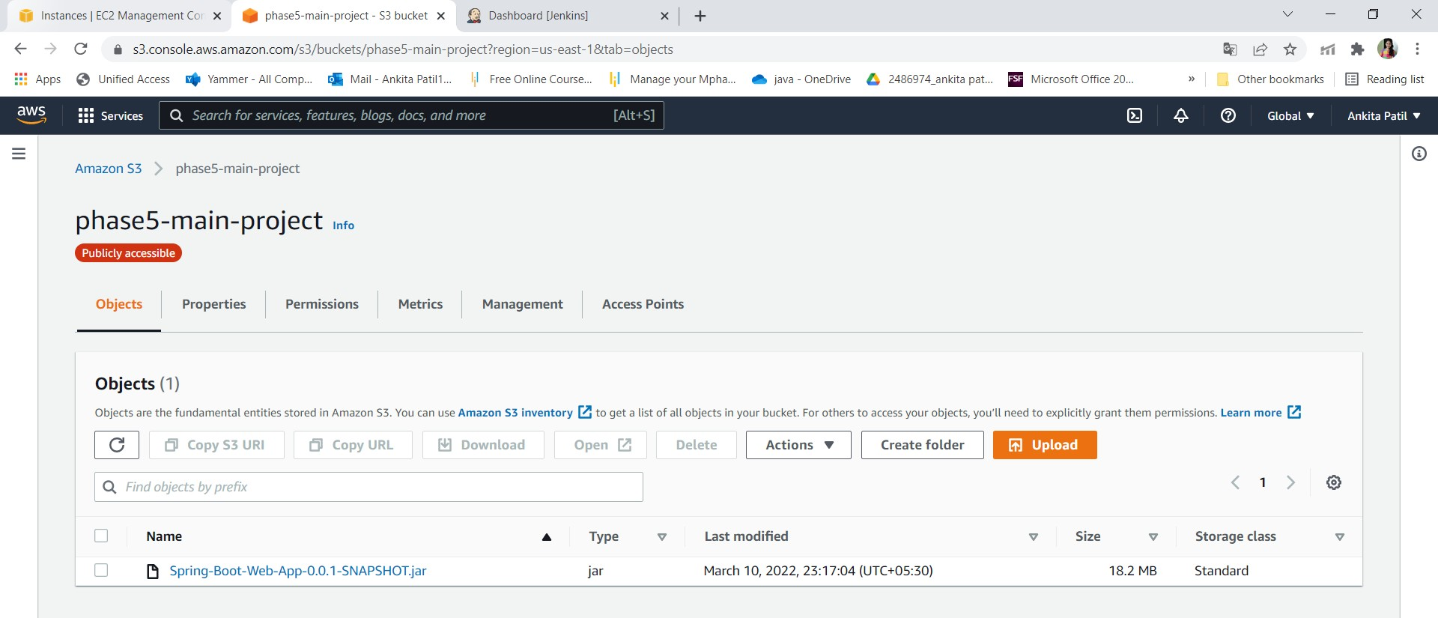

* + Run program through instance:

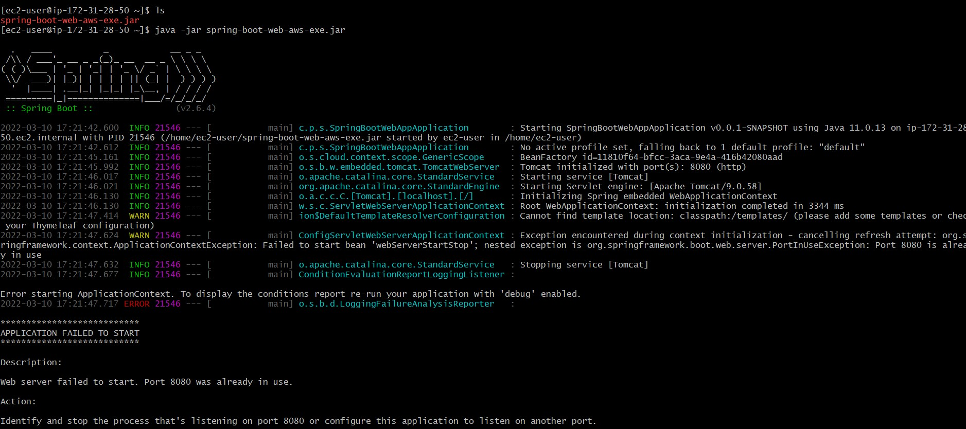

* + Output:

